Software Requirements Specification (SRS)
Project: Customer Relationship Management (CRM) System
Reach | Acquire | Convert | Retain | Loyalty
A simple CRM app which takes care of customers
Team | <Team Name>
Version | 1.1
Authors | <Team Members / SRNs>
Date | 29-09-2026
Status | Draft / For Review

Revision history
Version | Date | Author | Change summary | Approval
1.0 | 29-09-2026 | <Team> | Initial SRS prepared for the Simple CRM project. | Pending
1.1 | 29-09-2026 | <Team> | Restructured to follow the Team 3 SRS template: added glossary, references, priority conventions, assumptions and dependencies, feature groups by CRM lifecycle stage (Reach, Acquire, Convert, Retain, Loyalty), full RTM, risk register, and process-flow, state and ER diagrams. Added requirements CRM-F-004, 010, 012, 021, 033, 042, 051, 061, CRM-NF-006, CRM-SR-006 and CRM-SR-007. | Pending

Approvals
Role | Name | Signature / Email | Date
Course Coordinator
Team Lead

Table of Contents
1. Introduction
1.1 Purpose
1.2 Scope
1.3 Audience
1.4 Definitions, Acronyms and Glossary
1.5 References
1.6 Requirement Priority Conventions
2. Overall description
2.1 Product perspective
2.2 Major product functions
2.3 User roles and characteristics
2.4 Operating environment
2.5 Constraints
2.6 Assumptions and Dependencies
3. External interface requirements
4. System features (detailed)
5. Non-functional requirements (detailed)
6. Quality attributes & Acceptance tests
7. System models and diagrams
8. Requirements Traceability Matrix (RTM)
9. Risks and open issues
Appendix A. Suggested core data entities

1. Introduction

1.1 Purpose
This document is a Software Requirements Specification (SRS) for the Customer Relationship Management (CRM) System, a simple web-based application that takes care of customers across the five stages of the customer lifecycle: Reach, Acquire, Convert, Retain and Loyalty. It defines the functional and non-functional requirements, external interfaces, security controls and acceptance criteria, and serves as a reference for the development team, evaluators and stakeholders.

1.2 Scope
The system covers staff login and role-based access, outreach campaign records, lead capture and qualification, lead-to-customer conversion, customer profile management and search, interaction and follow-up tracking, feedback and issue handling, retention activities, loyalty points and rewards, dashboards and reports, notifications, and audit logging. It is intended as a simple CRM rather than a full enterprise CRM. Accounting, payment processing, marketing-automation platforms and ERP integration are outside the core scope.

1.3 Audience
Developers, QA Engineers, Project Evaluators, Sales Staff, Support Staff and System Administrators.

1.4 Definitions, Acronyms and Glossary
Acronyms used: CRM (Customer Relationship Management), UI (User Interface), API (Application Programming Interface), TLS (Transport Layer Security), HTTPS (Hypertext Transfer Protocol Secure), RBAC (Role-Based Access Control), CSV (Comma-Separated Values), PDF (Portable Document Format), SMS (Short Message Service), FR (Functional Requirement), NFR (Non-Functional Requirement).
The table below defines domain terms used throughout this document.
Term | Definition
Reach | Lifecycle stage in which the organization contacts potential customers through campaigns or other outreach channels.
Acquire | Lifecycle stage in which interested people are captured as leads and qualified.
Convert | Lifecycle stage in which a qualified lead becomes a customer.
Retain | Lifecycle stage in which existing customers are kept engaged through follow-up, feedback handling and retention activities.
Loyalty | Lifecycle stage in which repeat engagement is rewarded through points, tiers and rewards.
Lead | A potential customer who has shown interest or may be acquired.
Customer | A person or organization whose record was created directly or by converting a lead.
Conversion | Movement of a qualified lead into a customer record.
Interaction | A recorded communication or event such as a call, email, meeting or support contact.
Follow-up | A scheduled task with a due date, priority and responsible user, linked to a lead or customer.
Campaign | A recorded outreach activity (name, channel, date) that leads can be linked to.
Lifecycle status | The current position of a customer, for example Active, At Risk, Inactive or Loyal.
Loyalty tier | A level (for example Silver or Gold) reached when a customer's points cross a configured threshold.
Segment | A saved group of customers that share a lifecycle status, source or activity level.
Audit event | A timestamped record of who did what in the system.
RBAC | Role-Based Access Control: permissions are granted by role (Administrator, Sales Staff, Support Staff).

1.5 References
- IEEE Std 830-1998, IEEE Recommended Practice for Software Requirements Specifications.
- OWASP Top 10 - used as a general baseline when drafting the security requirements in Section 5.1.
- W3C, Web Content Accessibility Guidelines (WCAG) 2.1 - guidance for the usability requirement CRM-NF-003.
- Peer-to-Peer Tutoring Scheduler SRS (Team 3, v1.1) - used as the structural template for this document.
- Course project brief: "Customer Relationship Management (Reach, Acquire, Convert, Retain and Loyalty) - a simple CRM app which takes care of customers".

1.6 Requirement Priority Conventions
Priorities in Sections 4 and 5 follow the same three-level scale throughout this document:
- High - required for the system to function or directly supports a primary use case (login and access control, lead management, conversion, customer records, interactions, feedback, audit). The system is not acceptance-ready without these (see Section 6).
- Medium - improves completeness or usability but the system is still usable without it at initial release. First candidates to slip if the timeline gets tight.
- Low - backlog items identified during requirements gathering but not committed for v1.0 (currently only CRM-F-061, report export).

2. Overall description

2.1 Product perspective
The CRM is a standalone web application made up of a browser-based user interface, an application layer holding the business logic, and a relational database. Staff use it to manage leads and customers, while administrators manage users and configuration. It centralizes customer information and interaction history so that every lifecycle activity is tracked in one place. An external email/SMS service is used only for optional follow-up reminders.

2.2 Major product functions
The functions are grouped by the lifecycle stage they support:
Stage | What the system provides
Reach | Record outreach campaigns and channels; link leads to the campaign that reached them.
Acquire | Capture leads with source and owner; detect duplicates; qualify and assign leads.
Convert | Convert qualified leads into customers; mark unsuccessful leads as Lost; maintain customer profiles with search and filters.
Retain | Record interactions, follow-ups and reminders; handle feedback and complaints; track lifecycle status, retention activities and segments.
Loyalty | Maintain points, tiers and rewards; redeem rewards.
Supporting | Login and role-based access, staff account administration, dashboards and reports, notifications, audit logging.

2.3 User roles and characteristics
- Sales Staff: creates and qualifies leads, records campaigns, converts leads, updates customer records, records interactions and manages follow-ups.
- Support Staff: views customer history, records support interactions and feedback, supports retention activities and manages loyalty rewards.
- Administrator: manages users and roles, monitors activity through the audit log, configures basic CRM settings and accesses reports.
- Customer (optional portal): may view permitted profile and loyalty information and submit feedback, if the customer portal is implemented.

2.4 Operating environment
A web application accessed through modern desktop and mobile browsers (Chrome, Firefox, Edge, Safari, latest two major versions). The server side consists of an application server/runtime and a relational database on a standard server or cloud environment. The specific language, framework and database are selected during design.

2.5 Constraints
- Users must have valid accounts and an assigned role before using the system.
- Customer data is stored in a centralized database and only authorized staff may access it.
- Network access is required for normal operation.
- Optional email/SMS reminders depend on an external notification service and its rate limits.
- Version 1.0 focuses on core lifecycle management; AI features and marketing automation are out of scope.

2.6 Assumptions and Dependencies
- It is assumed that the organization supplies its own list of lead sources, lifecycle statuses, loyalty tiers and reward rules as configuration values.
- The optional reminder feature depends on a third-party email/SMS provider whose delivery time is outside the team's control (see 3.3, 3.4).
- Users are assumed to have a modern browser and a stable internet connection; offline use is not supported.
- The customer portal (role Customer) is optional and is not needed for acceptance of v1.0.
- The development team assumes access to a staging environment with a relational database for testing.
- Version 1.0 assumes a single organization; multi-organization support is out of scope.

3. External interface requirements

3.1 User interfaces
A responsive web UI with a dashboard, navigation menu, lead and customer forms, search and filter controls, an interaction timeline on each customer, a follow-up task list, reports, and role-specific administration screens. Forms show validation messages and confirmation feedback for important operations. Layouts work from 360 px to 1920 px width (CRM-NF-003).

3.2 Hardware interfaces
None. The system runs on standard laptops, tablets and smartphones through a web browser and on standard server or cloud infrastructure; no specialized hardware is required.

3.3 Software interfaces
- Backend REST API (JSON over HTTPS) used by the web front end.
- Relational database (e.g., PostgreSQL or MySQL) for users, leads, customers, interactions, follow-ups, feedback, loyalty and audit records.
- Authentication and authorization component for user identity and RBAC.
- Optional email/SMS notification service for follow-up reminders.
- Optional CSV/PDF export interface for reports (CRM-F-061).

3.4 Communications
All client-server communication uses HTTPS with TLS 1.2 or higher. The application handles failed requests gracefully and does not expose sensitive customer data in URLs or client-side error messages. Failed reminder sends are retried a limited number of times and then logged as failed.

4. System features (detailed)
Each requirement includes acceptance criteria and a reference test case. Functional IDs follow CRM-F-###, and the groups follow the customer lifecycle.

4.1 Authentication & User Management
Description: Login, role-based access, staff account administration and password handling.
Req ID | Requirement (shall...) | Type | Priority | Source | Acceptance criteria / Test ref | Comments
CRM-F-001 | The system shall authenticate a user using a valid username/email and password. | Functional | High | CRM Team | AC-001: Valid credentials create a session; invalid credentials are rejected with a generic error. Test: TC-Auth-01
CRM-F-002 | The system shall enforce role-based access for Administrator, Sales Staff and Support Staff. | Functional | High | CRM Team | AC-002: Users can open only the functions permitted for their role. Test: TC-Auth-02 | Uses RBAC (see CRM-SR-003)
CRM-F-003 | The system shall allow an administrator to create, update and deactivate staff accounts and assign roles. | Functional | High | Administrator | AC-003: Administrator can manage staff accounts; a deactivated user cannot log in. Test: TC-Admin-01
CRM-F-004 | The system shall allow a user to change their password, and to reset a forgotten password through a time-limited link. | Functional | Medium | Sales / Support Staff | AC-004: Reset link expires after 30 minutes and works only once. Test: TC-Auth-03 | Uses email service

4.2 Reach & Acquire (Campaigns and Leads)
Description: Outreach campaigns and the capture, de-duplication, qualification and assignment of leads.
Req ID | Requirement (shall...) | Type | Priority | Source | Acceptance criteria / Test ref | Comments
CRM-F-010 | The system shall allow authorized users to record an outreach campaign (name, channel, start date, target segment) so that leads can be linked to the channel that reached them. | Functional | Medium | Sales Staff | AC-010: A saved campaign can be selected as the source when a lead is created. Test: TC-Reach-01 | Supports the Reach stage
CRM-F-011 | The system shall create and track leads with source, status, owner and contact information. | Functional | High | Sales Staff | AC-011: A lead is created with a unique identifier and the default status "New". Test: TC-Lead-01 | Supports the Acquire stage
CRM-F-012 | The system shall warn the user when a new lead or customer has the same email or phone number as an existing record. | Functional | Medium | Sales Staff | AC-012: A possible-duplicate warning is shown and the user may cancel or continue. Test: TC-Lead-02
CRM-F-013 | The system shall allow authorized users to qualify, update and assign leads to a staff owner. | Functional | High | Sales Staff | AC-013: Changes to lead status and owner are saved and visible on reload. Test: TC-Lead-03

4.3 Convert & Customer Records
Description: Lead conversion, lost leads, and customer profile creation, update and search.
Req ID | Requirement (shall...) | Type | Priority | Source | Acceptance criteria / Test ref | Comments
CRM-F-020 | The system shall convert a qualified lead into a customer without re-entering or duplicating core contact information. | Functional | High | Sales Staff | AC-020: Conversion creates or links a customer record and marks the lead "Converted". Test: TC-Conv-01 | Supports the Convert stage
CRM-F-021 | The system shall allow an authorized user to mark a lead as Lost and record the reason. | Functional | Medium | Sales Staff | AC-021: A Lost lead is excluded from the active lead list and keeps its reason. Test: TC-Conv-02
CRM-F-022 | The system shall create and store a customer profile containing name, contact details, source and lifecycle status. | Functional | High | CRM Team | AC-022: A valid profile is saved and can be retrieved. Test: TC-Cust-01
CRM-F-023 | The system shall allow authorized users to update customer profile information. | Functional | High | CRM Team | AC-023: Updated values are saved and shown after reload. Test: TC-Cust-02
CRM-F-024 | The system shall search and filter customers by name, phone/email, lifecycle status and source. | Functional | High | CRM Team | AC-024: Matching records are returned for valid search and filter criteria. Test: TC-Cust-03

4.4 Interactions & Follow-ups
Description: Communication history and scheduled follow-up activities with reminders.
Req ID | Requirement (shall...) | Type | Priority | Source | Acceptance criteria / Test ref | Comments
CRM-F-030 | The system shall record customer interactions (call, email, meeting or support contact) with date, type, owner and notes. | Functional | High | Sales / Support Staff | AC-030: The interaction appears in the customer's history after saving. Test: TC-Int-01
CRM-F-031 | The system shall allow users to schedule follow-up activities with due date, priority and responsible user. | Functional | High | Sales / Support Staff | AC-031: A scheduled follow-up appears in the responsible user's task list. Test: TC-FU-01
CRM-F-032 | The system shall generate reminders for due and upcoming follow-up activities. | Functional | Medium | Sales / Support Staff | AC-032: A reminder is generated according to the configured reminder rule. Test: TC-FU-02 | Optional email/SMS
CRM-F-033 | The system shall allow a follow-up to be marked completed or rescheduled, and shall flag overdue follow-ups. | Functional | Medium | Sales / Support Staff | AC-033: Completed items leave the open list; overdue items are visibly flagged. Test: TC-FU-03

4.5 Retain (Feedback & Retention)
Description: Feedback and complaint handling, lifecycle status, retention activities and segmentation.
Req ID | Requirement (shall...) | Type | Priority | Source | Acceptance criteria / Test ref | Comments
CRM-F-040 | The system shall record customer feedback, complaints or service issues and track their status through configured stages. | Functional | High | Support Staff | AC-040: Feedback is stored and its status can move Open, In Progress, Resolved, Closed. Test: TC-FB-01 | Supports the Retain stage
CRM-F-041 | The system shall maintain a customer lifecycle/retention status and allow authorized staff to record retention activities. | Functional | Medium | Support Staff | AC-041: A retention activity is linked to the customer and visible in history. Test: TC-Ret-01
CRM-F-042 | The system shall allow customers to be grouped into segments by lifecycle status, source and activity level. | Functional | Medium | Sales Staff | AC-042: A segment filter returns exactly the customers matching its rule. Test: TC-Ret-02

4.6 Loyalty
Description: Loyalty points, tiers, rewards and redemption.
Req ID | Requirement (shall...) | Type | Priority | Source | Acceptance criteria / Test ref | Comments
CRM-F-050 | The system shall maintain loyalty information (points, tier and eligible rewards) for each customer when the loyalty feature is enabled. | Functional | Medium | CRM Team | AC-050: Authorized point updates are calculated, stored and shown on the customer record. Test: TC-Loy-01 | Supports the Loyalty stage
CRM-F-051 | The system shall allow a reward to be redeemed against a customer's points and shall not allow the balance to fall below zero. | Functional | Medium | Support Staff | AC-051: Redemption reduces the balance; a redemption above the balance is rejected. Test: TC-Loy-02

4.7 Dashboards, Reports & Audit
Description: Management information, report export and audit logging.
Req ID | Requirement (shall...) | Type | Priority | Source | Acceptance criteria / Test ref | Comments
CRM-F-060 | The system shall provide dashboards and reports showing lead counts, conversions, active customers, follow-ups and retention indicators. | Functional | Medium | Administrator | AC-060: Report values match the database for the test dataset. Test: TC-Rep-01
CRM-F-061 | The system shall allow a report to be exported as CSV or PDF. | Functional | Low | Administrator | AC-061: The exported file contains the same rows as the on-screen report. Test: TC-Rep-02 | Backlog item, not committed for v1.0
CRM-F-062 | The system shall record an audit event for important actions such as login, customer modification, lead conversion and user-role changes. | Functional | High | Administrator | AC-062: Each required event contains actor, action and timestamp. Test: TC-Audit-01

5. Non-functional requirements (detailed)
The requirements below are measurable and tied to test cases. IDs follow CRM-NF-###.
Req ID | Requirement | Category | Priority | Acceptance criteria / Measurement
CRM-NF-001 | 95% of common operations (customer search, profile retrieval) shall complete within 3 seconds under normal load. | Performance | High | 95th percentile ≤ 3 s in a production-like load test. Test: TC-Perf-01
CRM-NF-002 | The system shall maintain at least 99.0% monthly availability, excluding planned maintenance. | Reliability | High | Monitoring report shows ≥ 99.0% per month. Test: TC-Rel-01
CRM-NF-003 | The web UI shall be usable on screen widths from 360 px (mobile) to 1920 px (desktop) and shall show clear validation and error messages. | Usability | Medium | Usability checklist passes on supported browsers and sizes. Test: TC-UX-01
CRM-NF-004 | The system shall keep timestamped audit records for security-sensitive and business-critical actions and support a configured retention period. | Auditability | High | Audit records can be queried and linked to the responsible user. Test: TC-Audit-02
CRM-NF-005 | The system shall support backup and recovery of CRM data with a documented recovery procedure. | Recoverability | High | A restore test reconstructs the test dataset. Test: TC-Backup-01
CRM-NF-006 | The system shall support at least 50 staff users and 10,000 customer records without degrading the response-time target. | Scalability | Medium | Load test with the target data volume meets CRM-NF-001. Test: TC-Perf-02

5.1 Security

5.1.1 Security Objectives
- Protect customer and staff data from unauthorized access or disclosure.
- Ensure that only authenticated, authorized users can view or change customer, lead and loyalty records.
- Preserve the integrity and traceability of customer, lead, interaction and loyalty records.

5.1.2 Security Requirements
Req ID | Requirement (shall...) | Type | Priority | Acceptance criteria / Test ref
CRM-SR-001 | The system shall enforce HTTPS/TLS for all client-server communication. | Security | High | HTTP is redirected or blocked; TLS verified by scan. Test: TC-Sec-01
CRM-SR-002 | The system shall store passwords only as strong salted hashes and never as plaintext. | Security | High | Database inspection shows no plaintext passwords. Test: TC-Sec-02
CRM-SR-003 | The system shall enforce RBAC so that users cannot reach customer data or administrative functions outside their permissions. | Security | High | Unauthorized requests return 403 and are logged. Test: TC-Sec-03
CRM-SR-004 | The system shall protect against SQL injection and cross-site scripting using parameterized queries, input validation and output encoding. | Security | High | Security scan finds no injection or script-execution flaws. Test: TC-Sec-04
CRM-SR-005 | The system shall record security-relevant events (login failures, account and permission changes) without logging passwords. | Security | High | Events hold timestamp, user and action; no credentials present. Test: TC-Sec-05
CRM-SR-006 | The system shall limit repeated failed logins (temporary lockout or back-off) and end idle sessions after a configured time. | Security | Medium | Lockout triggers after repeated failures; idle session expires. Test: TC-Sec-06
CRM-SR-007 | The system shall retain customer personal data only for a defined period after a customer is deleted or requests removal, after which it shall be purged or anonymized. | Security/Privacy | Medium | Purge job removes or anonymizes data after the configured window (e.g., 90 days). Test: TC-Sec-07

5.1.3 Data Privacy & Retention
The CRM stores personal contact details and communication history of identifiable customers, so retention and minimization matter in addition to encryption and access control. CRM-SR-007 makes this testable: personal data is kept while the customer record is active and for a defined window after deletion or a removal request, and is then purged or anonymized rather than kept indefinitely. Audit records keep the actor and action but not the removed personal details.

6. Quality attributes & Acceptance tests

6.1 Quality attributes
- Performance: common operations meet the 3-second response target (CRM-NF-001).
- Reliability: the service stays available and recovers from expected failures (CRM-NF-002, CRM-NF-005).
- Security: authentication, authorization, secure communication and audit controls are enforced (Section 5.1).
- Usability: screens are understandable and workflows need few unnecessary steps (CRM-NF-003).
- Maintainability: modular separation of UI, business logic and data access allows changes without widespread impact.
- Data integrity: customer and lead records stay consistent during create, update and convert operations.

6.2 Acceptance criteria
Exit criteria for acceptance: all High-priority functional requirements are implemented and verified, all High-priority non-functional and security requirements meet their measurable criteria, no critical defects remain open, and the RTM (Section 8) shows all associated test cases passed. Priority definitions are given in Section 1.6.

6.3 Acceptance test suites
Authentication & RBAC, Campaigns & Leads, Conversion & Customer Management, Interaction & Follow-up, Feedback & Retention, Loyalty, Reports & Administration, Performance & Reliability, Security, and Backup & Recovery.

7. System models and diagrams

7.1 UML Use-Case diagrams
Two use-case diagrams describe the actors. Sales Staff performs lead, conversion, customer, interaction and follow-up work (Figure 7.1). Support Staff records feedback, retention activities and loyalty updates; the Administrator manages accounts, reports and the audit log; the optional Customer uses the portal; and an external Email/SMS Service takes part in the Send Follow-up Reminder use case (Figure 7.2).
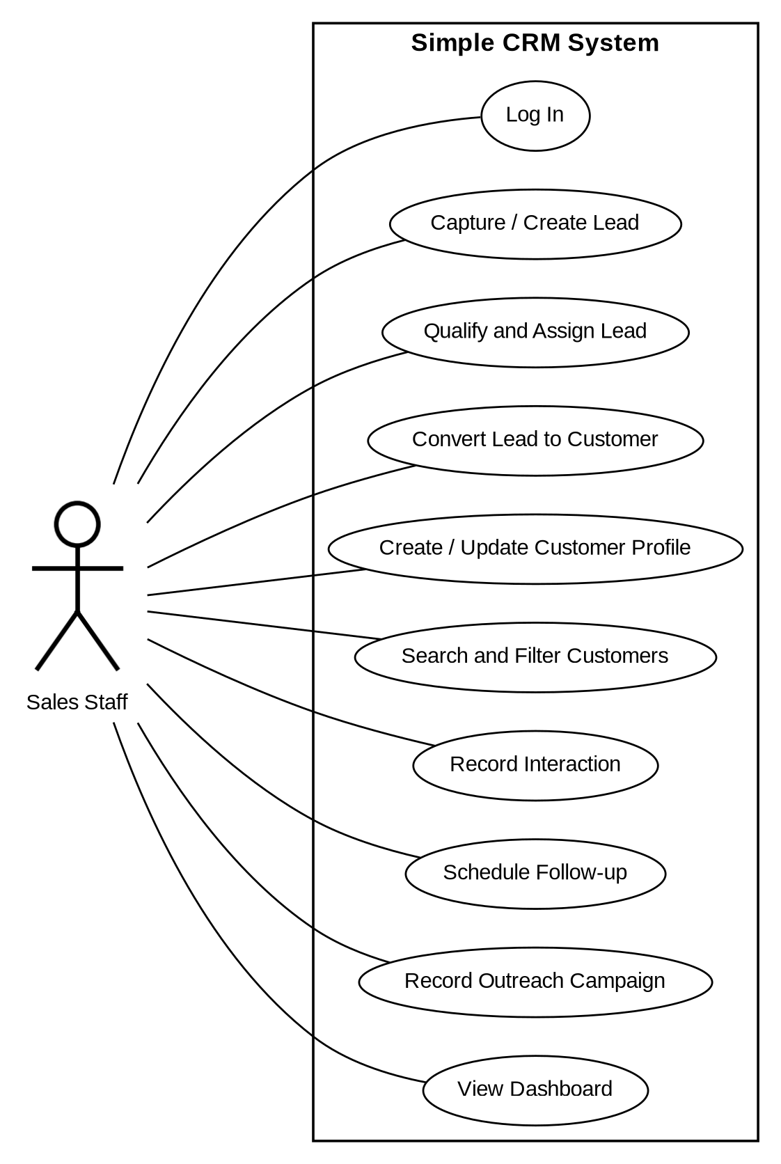
Figure 7.1 - Sales Staff use-case diagram
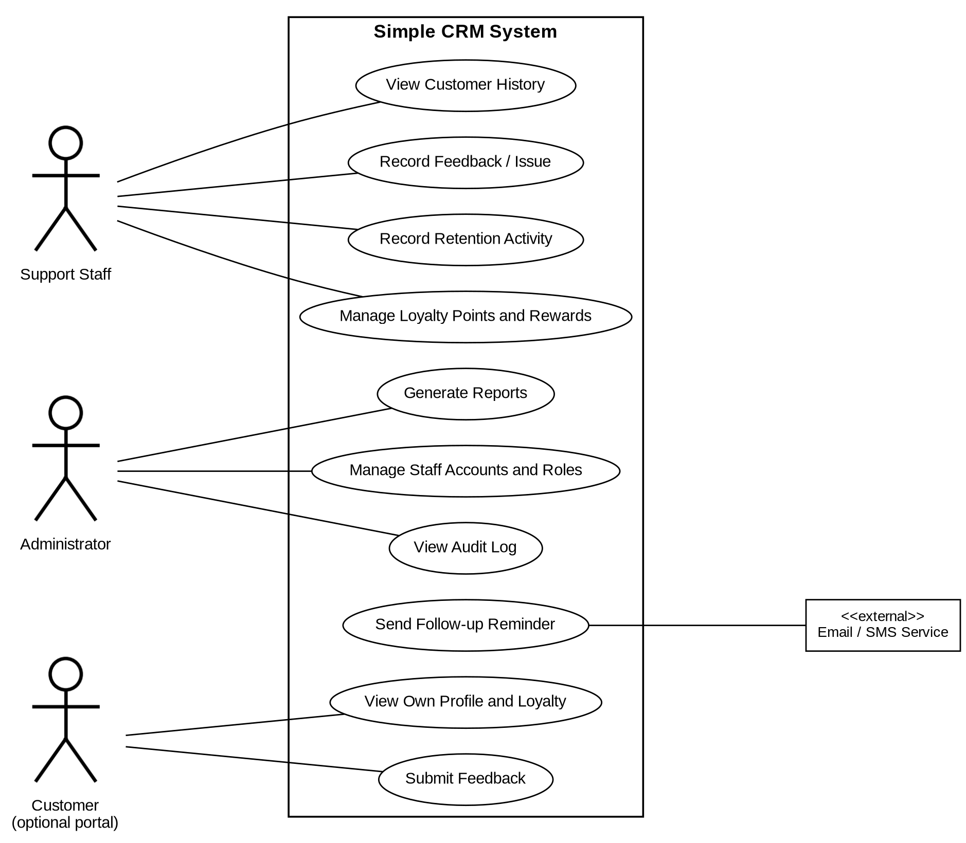
Figure 7.2 - Support Staff, Administrator, Customer and Email/SMS Service use-case diagram

7.2 Lead conversion - process flow
This diagram walks through CRM-F-020. A lead can be converted only when it is Qualified. Before a new customer is created, the system checks for an existing customer with the same email or phone number (CRM-F-012) and links to it instead of duplicating contact data. After conversion, the lead is marked Converted, its history is carried over and an audit event is written (CRM-F-062).
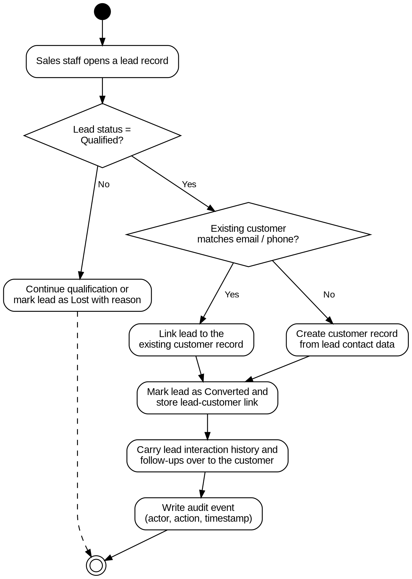
Figure 7.3 - Lead conversion process flow

7.3 Lead and customer lifecycle - state diagrams
A lead starts as New, becomes Contacted after first contact, and Qualified when it meets the criteria. A Qualified lead is Converted into a customer (CRM-F-020). At any point before conversion it can be marked Lost with a reason (CRM-F-021) and may later be reopened.
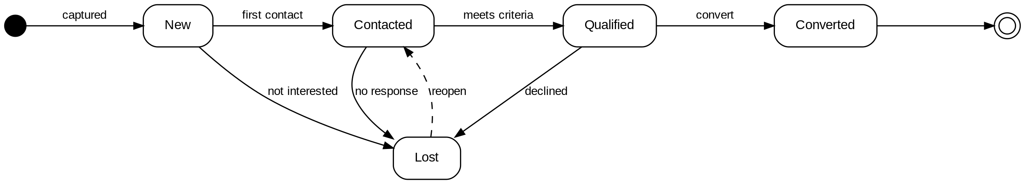
Figure 7.4 - Lead status state diagram
Once converted, a customer is Active. A long gap without interaction or an open complaint moves the customer to At Risk; a successful retention activity returns them to Active, while no response leads to Inactive. Customers who reach the configured loyalty threshold become Loyal (CRM-F-041, CRM-F-050).
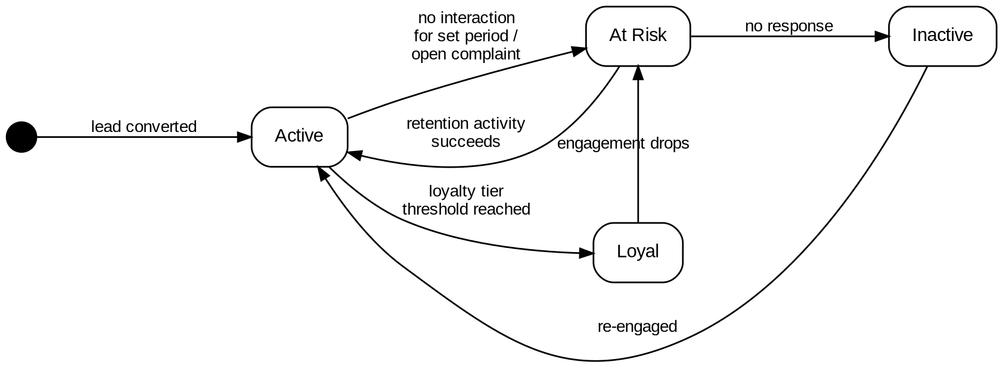
Figure 7.5 - Customer lifecycle state diagram

7.4 Data model - ER diagram
The core entities are User, Campaign, Lead, Customer, Interaction, FollowUp, Feedback, RetentionActivity, LoyaltyAccount and AuditLog. A campaign reaches many leads; a lead converts to at most one customer. A customer has many interactions, follow-ups, feedback items and retention activities, and exactly one loyalty account. Users own leads and record interactions, and every important action creates an audit entry.
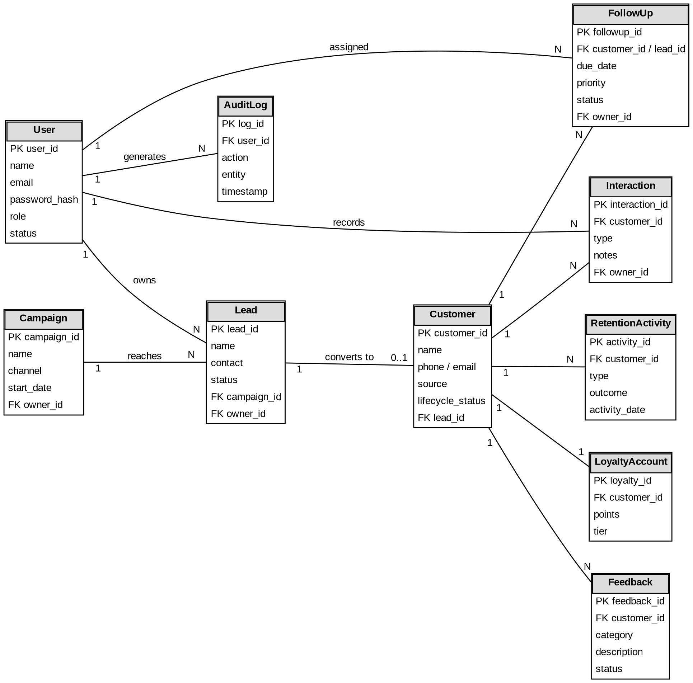
Figure 7.6 - Entity-relationship diagram

8. Requirements Traceability Matrix (RTM)
Status column uses N = Not started, P = In progress, A = Accepted/passed. All rows are currently N since implementation has not begun.
Req ID | Requirement (short) | Sec. | Module | Test case(s) | Status | Comments
CRM-F-001 | Login with username/email and password | 4.1 | AuthModule | TC-Auth-01 | N
CRM-F-002 | Role-based access (Admin / Sales / Support) | 4.1 | AuthModule | TC-Auth-02 | N
CRM-F-003 | Admin manages staff accounts | 4.1 | AdminModule | TC-Admin-01 | N
CRM-F-004 | Change / reset password | 4.1 | AuthModule | TC-Auth-03 | N
CRM-F-010 | Record outreach campaign | 4.2 | CampaignModule | TC-Reach-01 | N
CRM-F-011 | Create and track leads | 4.2 | LeadModule | TC-Lead-01 | N
CRM-F-012 | Duplicate lead/customer warning | 4.2 | LeadModule | TC-Lead-02 | N
CRM-F-013 | Qualify, update and assign leads | 4.2 | LeadModule | TC-Lead-03 | N
CRM-F-020 | Convert lead to customer | 4.3 | ConversionModule | TC-Conv-01 | N | Core feature
CRM-F-021 | Mark lead Lost with reason | 4.3 | LeadModule | TC-Conv-02 | N
CRM-F-022 | Create customer profile | 4.3 | CustomerModule | TC-Cust-01 | N
CRM-F-023 | Update customer profile | 4.3 | CustomerModule | TC-Cust-02 | N
CRM-F-024 | Search / filter customers | 4.3 | CustomerModule | TC-Cust-03 | N
CRM-F-030 | Record interactions | 4.4 | InteractionModule | TC-Int-01 | N
CRM-F-031 | Schedule follow-ups | 4.4 | TaskModule | TC-FU-01 | N
CRM-F-032 | Follow-up reminders | 4.4 | TaskModule / Notification | TC-FU-02 | N
CRM-F-033 | Complete / reschedule / flag overdue | 4.4 | TaskModule | TC-FU-03 | N
CRM-F-040 | Record feedback and issues | 4.5 | FeedbackModule | TC-FB-01 | N
CRM-F-041 | Lifecycle status and retention activities | 4.5 | RetentionModule | TC-Ret-01 | N
CRM-F-042 | Customer segmentation | 4.5 | CustomerModule | TC-Ret-02 | N
CRM-F-050 | Loyalty points, tier and rewards | 4.6 | LoyaltyModule | TC-Loy-01 | N
CRM-F-051 | Reward redemption | 4.6 | LoyaltyModule | TC-Loy-02 | N
CRM-F-060 | Dashboards and reports | 4.7 | ReportingModule | TC-Rep-01 | N
CRM-F-061 | Export report (CSV / PDF) | 4.7 | ReportingModule | TC-Rep-02 | N | Low priority
CRM-F-062 | Audit event logging | 4.7 | AuditModule | TC-Audit-01 | N
CRM-NF-001 | Response time (p95 ≤ 3 s) | 5 | Application / API | TC-Perf-01 | N
CRM-NF-002 | 99.0% monthly availability | 5 | Infra | TC-Rel-01 | N
CRM-NF-003 | Responsive UI 360–1920 px | 5 | Frontend | TC-UX-01 | N
CRM-NF-004 | Audit records and retention | 5 | AuditModule | TC-Audit-02 | N
CRM-NF-005 | Backup and recovery | 5 | Infra | TC-Backup-01 | N
CRM-NF-006 | 50 users / 10,000 customers | 5 | Infra | TC-Perf-02 | N
CRM-SR-001 | TLS everywhere | 5.1.2 | Infra | TC-Sec-01 | N
CRM-SR-002 | Password hashing | 5.1.2 | AuthModule | TC-Sec-02 | N
CRM-SR-003 | RBAC enforcement | 5.1.2 | AuthModule | TC-Sec-03 | N
CRM-SR-004 | Injection / XSS protection | 5.1.2 | API / Data layer | TC-Sec-04 | N
CRM-SR-005 | Security event logging | 5.1.2 | AuditModule | TC-Sec-05 | N
CRM-SR-006 | Login throttling, session timeout | 5.1.2 | AuthModule | TC-Sec-06 | N
CRM-SR-007 | Data retention and purge | 5.1.3 | CustomerModule | TC-Sec-07 | N

9. Risks and open issues
These are risks identified while writing this SRS and are not yet mitigated in code. They are listed to help planning and are not a guarantee that each item is handled by launch.
Risk | Likelihood | Impact | Mitigation / Notes
Duplicate customer or lead records reduce data quality and distort reports. | Medium | Medium | Duplicate warning on email/phone (CRM-F-012) and link-instead-of-copy on conversion (CRM-F-020).
Unauthorized access to personal customer data through weak role checks. | Low | High | RBAC (CRM-SR-003), password hashing, TLS, audit logging; verify with security test cases before release.
Email/SMS provider outage or rate limits delay follow-up reminders. | Medium | Low | Reminders are optional; in-app task list remains the source of truth (CRM-F-031).
Scope growth toward a full enterprise CRM (marketing automation, accounting, ERP). | Medium | Medium | Explicitly out of scope in 1.2; new items go to the Low-priority backlog.
Loyalty rules (points, tiers) are not defined by the organization before development. | Medium | Low | Treat rules as configuration values (2.6); use simple defaults for testing.
Team velocity vs. course timeline; some Medium items (segmentation, loyalty redemption) may slip. | Medium | Low | High-priority items first per 1.6; Medium items are stretch goals for the final submission.

Appendix A. Suggested core data entities
Entity | Representative fields
User | user_id, name, email, password_hash, role, status, created_at
Campaign | campaign_id, name, channel, start_date, target_segment, owner_id
Lead | lead_id, name, contact, source, campaign_id, status, owner_id, lost_reason, created_at
Customer | customer_id, name, phone, email, source, lifecycle_status, lead_id, created_at
Interaction | interaction_id, customer_id, type, notes, interaction_date, owner_id
FollowUp | followup_id, customer_id / lead_id, due_date, priority, status, owner_id
Feedback | feedback_id, customer_id, category, description, status, created_at
RetentionActivity | activity_id, customer_id, type, outcome, activity_date, owner_id
LoyaltyAccount | loyalty_id, customer_id, points, tier, updated_at
AuditLog | log_id, user_id, action, entity, entity_id, timestamp

